Noise = 0.3, efficacy = 0.9, reward(non-completed, completed) = -1.0, 3.0  
 cost(check, work) = -0.1, -1.0

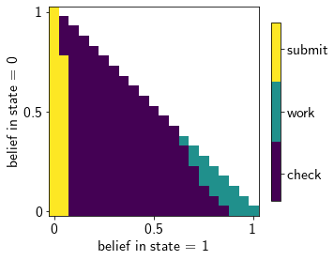

initial_state = 0 initial_state = 1

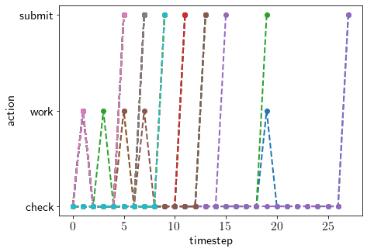 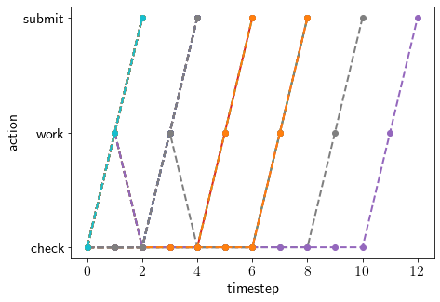

Starting in state 0: procrastination is due to evidence towards 0 (but you want to make sure this is true)

Starting in state 1: procrastination is due to wrong evidence away from 1 or due to not progressing despite working

Noise = 0.3, efficacy = 0.9, reward(non-completed, completed) = 0.0, 3.0  
 cost(check, work) = -0.1, -1.0

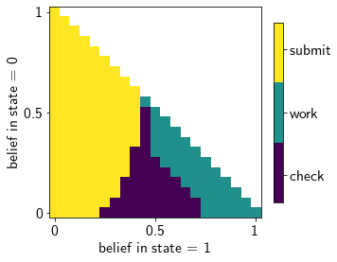

initial_state = 0 initial_state = 1

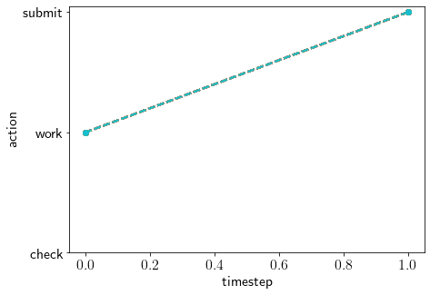 

Noise = 0.4, efficacy = 0.9, reward(non-completed, completed) = -1.0, 3.0  
 cost(check, work) = -0.1, -1.0

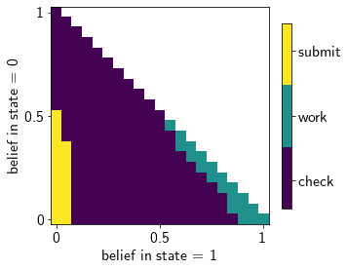

Initial_state = 0 initial_state = 1

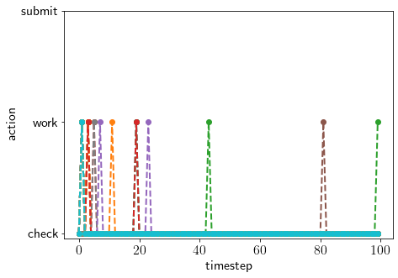 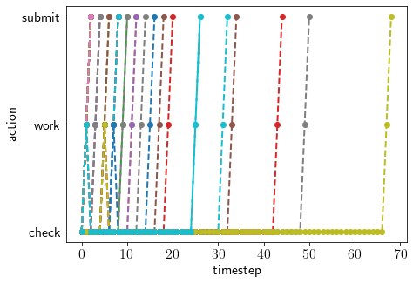

Noise = 0.3, efficacy = 0.7, reward(non-completed, completed) = -1.0, 3.0  
 cost(check, work) = -0.1, -1.0

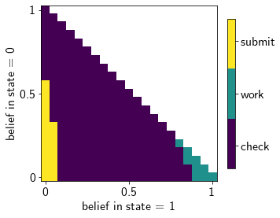

Initial_state = 0 initial_state = 1

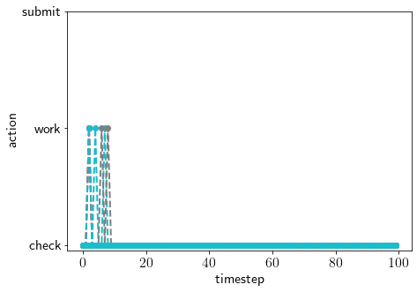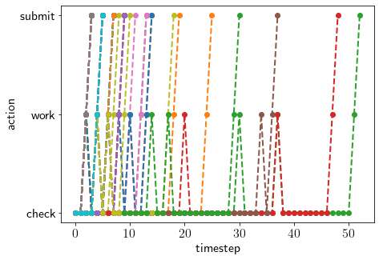

Here, the area where the agent should submit shrinks (with reduced efficacy) : because future probability of averting danger is low, the agent rather procrastinates forever (due to this opportunity cost).  
So to remove this from the problem, have a terminating state instead of a resetting mechanism. So now, submit transitions agent to a terminal state

Noise = 0.3, efficacy = 0.9, reward(non-completed, completed) = 0.0, 5.0  
 cost(check, work) = -0.1, -1.5

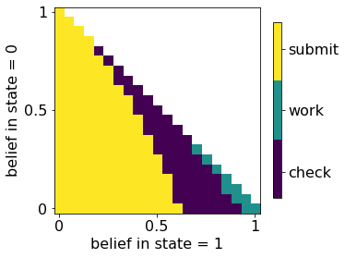

Initial_state=0 initial_state = 1

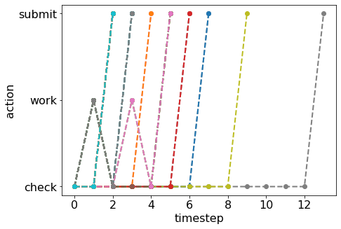 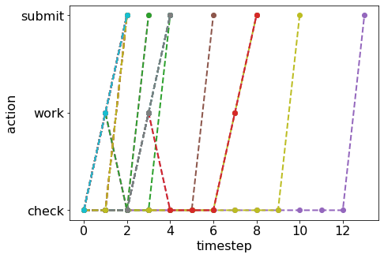

Noise = 0.3, efficacy = 0.7, reward(non-completed, completed) = 0.0, 5.0  
 cost(check, work) = -0.1, -1.5

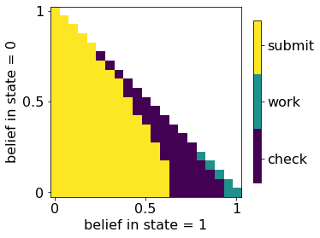

initial_state=0 initial_state=1

